Assignment

Submitted to Ma’m Yasmeen Jana
Submitted by Sahwana Ilyas
Registration no SP24-BSE-025
Course Web Technologies
Date 16-03-2026

COMSATS University Islamabad
Vehari Campus



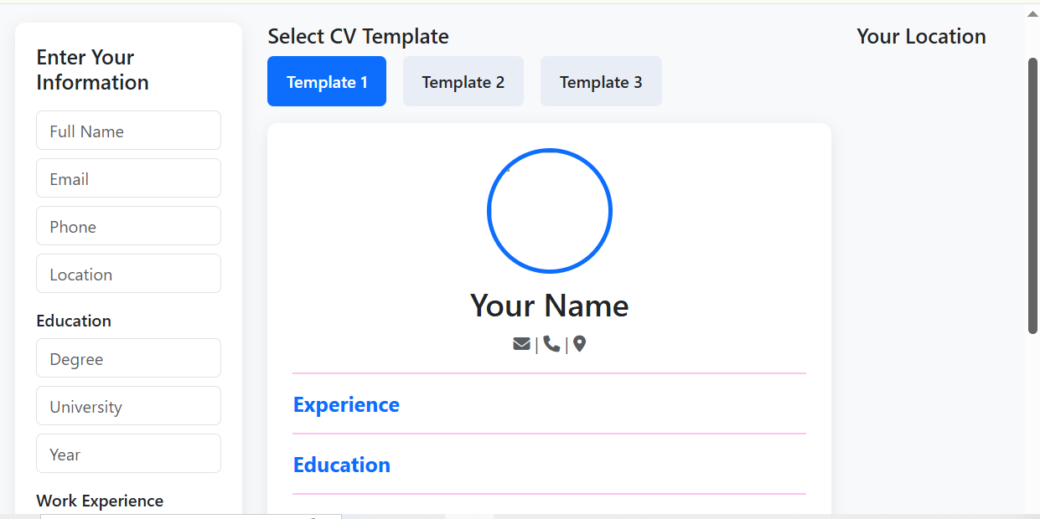
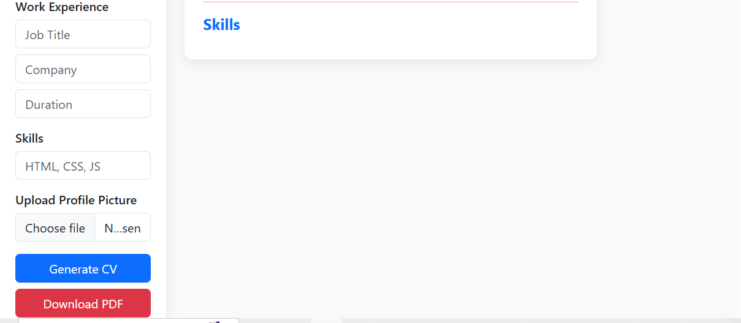

Output of my cv:
https://github.com/suhanailyas/sahwanaIlyas/blob/main/cv.zip

